FLUID MECHANICS
Physical science dealing with the action of fluids at rest or in motion.

Fluid statics: deals with fluids at rest
Fluid dynamics: concerned with fluids in motion
Hydraulics: laws controlling the behavior of water and other liquids at rest and in motion. It deals with such problems as the flow of fluids through pipes or in open channel, design of storage dams, pumps, and with other devices for the control or use of liquids such as nozzles, etc.
Hydrostatics: study of liquids at rest.
Hydrokinetics: deals with geometry of motion of liquids without considering the forces causing that motion.
Hydrodynamics: deals with forces exerted by or upon liquids in motion including relations between velocities and accelerations involved in such fluid motion.
Fluid: any substance that deforms continuously so long as shear stress is applied.
Density: mass of a fluid per unit volume and affects flow rate, buoyancy, and energy requirement in pumping systems. It affects the design of fluid storage and distribution systems and helps calculate the force needed to move water through pipes and canals.
Specific gravity: dimensionless property that is the ratio of a fluid’s density to that of water (reference density)
Compressibility: change in fluid volume under pressure. Most liquids are considered incompressible for ease of calculations, however, systems where gases are involved such as pneumatic systems or air-assisted spraying influences the system’s efficiency and energy consumption.
Capillary: the ability of a fluid to move through small spaces due to adhesive and cohesive forces.
Surface Tension: affects the behavior of liquids at the interface with other materials.
Pressure: determined by depth, density, and gravity. It ensures even water distribution, reducing energy costs and optimizing water use.

IDEAL FLUIDS | REAL FLUIDS
Assumed to have no viscosity (and hence, no resistance to shear) | Exhibit infinite viscosities
Incompressible | Compressible
Have uniform velocity when flowing | Non-uniform velocity distribution when flowing
No friction between moving layers of fluid and no eddy currents or turbulence | Experience friction and turbulence in flow

FLUID PROPERTIES
- Weight (W): earth’s gravitational pull upon a body (N)

- Mass (m): quantitative measure of the amount of matter in a given body (kg)
- Unit weight or specific weight ($γ$): weight of fluid contained in a unit volume ($N/m^{3}$).
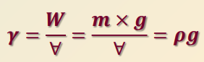
- Density ($ρ$): mass of fluid contained in a unit volume ($kg/m^{3}$).
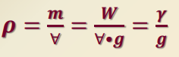
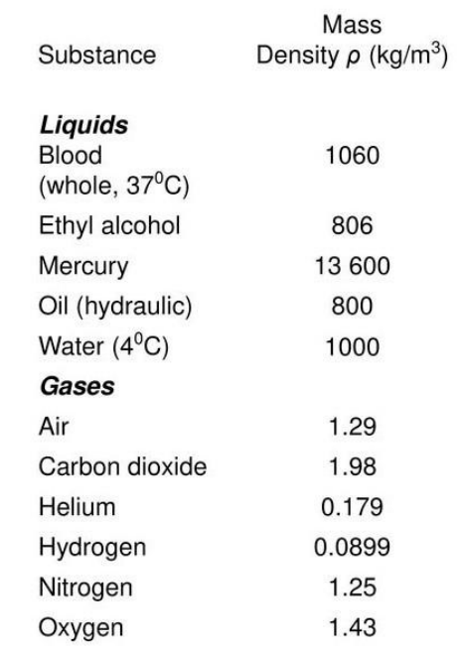
- Specific volume (v): volume per unit of mass of fluid; inverse of density ${(m}^{3}/kg)$.
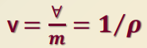
- Specific gravity (sg): dimensionless ratio of the specific weight or density of a fluid to the specific weight or density of a standard substance.
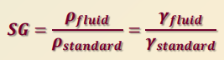
- Compressibility ($β$): frictional change in volume of a fluid per unit change in pressure in a constant-temperature process.
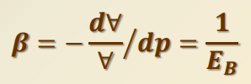
- Bulk Modulus of Elasticity ($E_{B}$): expresses the compressibility of a fluid
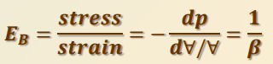
- Dynamic Viscosity or Absolute Viscosity ($μ$): measure of a fluid’s resistance to shear (Pa-s and Poise). 1 poise = 0.1 Pa-s
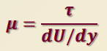
- Kinematic Viscosity ($υ$): ratio of the absolute viscosity to density ($m^{2}/s$ and Stoke). 1 Stoke = 0.0001 $m^{2}/s$
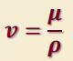

A | PRINCIPLES OF HYDROSTATICS

FLUID STATICS

Deals with hydrostatic conditions, which assume the following:
- There are no shear stresses in the fluid;
- Only normal forces are present; and
- The force per unit area acting normal to the surface is given by pressure,
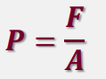
PASCAL’S LAW
- Blaise Pascal
- The pressure on a fluid is equal in all directions and in all parts of the container.

Scales of Pressure

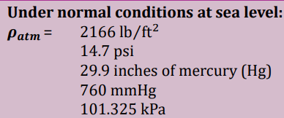

Energy Contained in a Fluid (head)
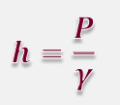

B | DAMS

- Structures that block the flow of a river, stream, or other waterway.
- Some divert the flow of river water into a pipeline, canal, or channel. Others raise the level of inland waterways
- Many dams harness the energy of falling water to generate electric power.
- Dams also hold water for drinking and crop irrigation, and provide flood control.

TYPES OF DAMS

Gravity Dams
Use only the force of gravity to resist water pressure.
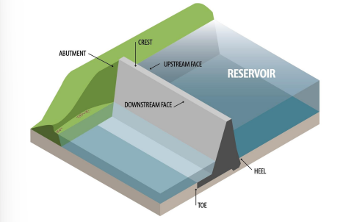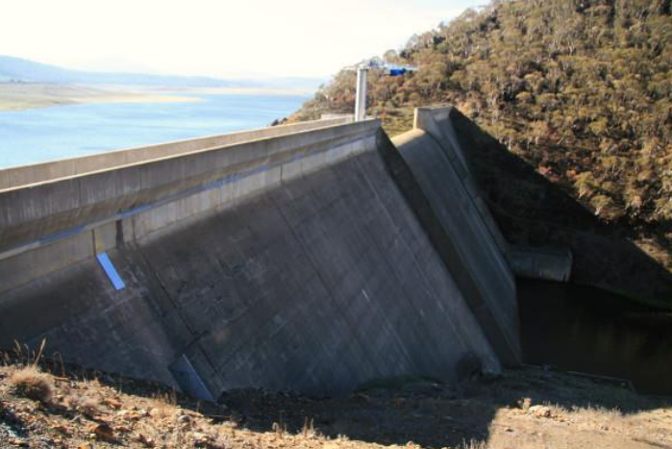

Embankment Dam
A gravity dam formed out of loose rock, earth, or a combination of these materials.
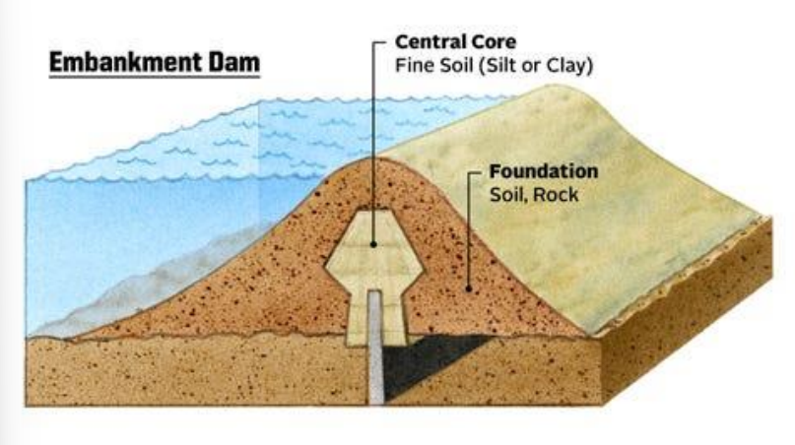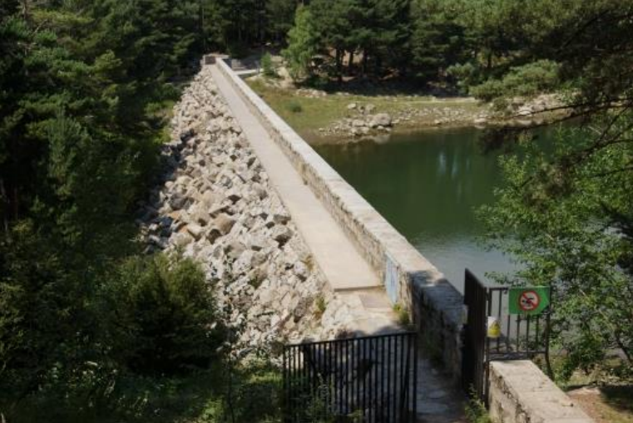

Arch Dams
Concrete or masonry structures that curve upstream into a reservoir. Stretching from one wall of a river canyon to the other.
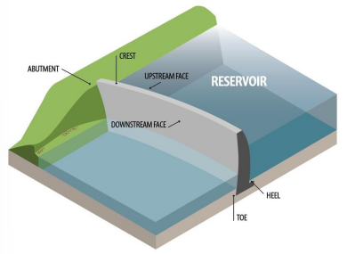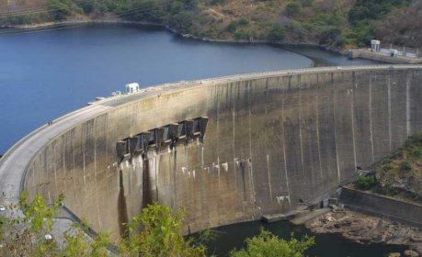

Buttress Dam
Consists of a wall, or face, supported by several buttresses on the downstream side.
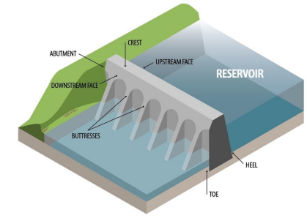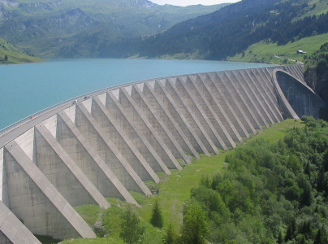

ANALYSIS OF GRAVITY DAMS
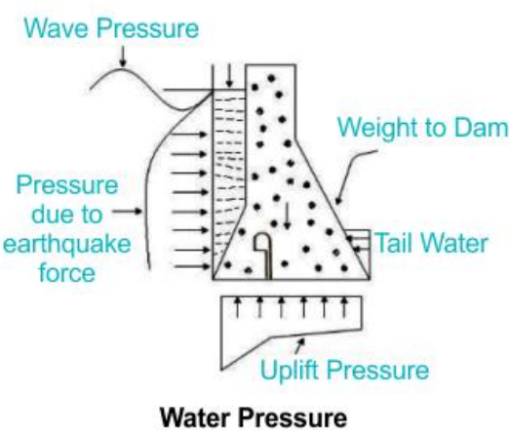
Uplift pressure: pressure under gravity dam producing an overturning effect.
Wave pressure: arises from the wind-driven waves on the reservoir surface, exerting pressure on the dam’s upstream force.

C | BUOYANCY

ARCHIMEDES’ PRINCPLE
- Also known as the law of hydrostatics
- “Any body immersed in a fluid is acted upon by an upward force (buoyant force) equal to the weight of the displaced fluid”

Buoyancy
An object immersed or floating in a certain fluid is acted upon by an upward force equal to the weight of the fluid displaced,
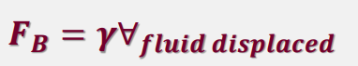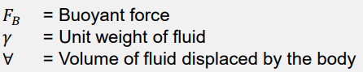

D | FUNDAMENTALS OF FLUID FLOW

Fluids in motion is based on the following principles:
- The principle of conservation of mass
- The energy principle (kinetic and potential)
- The principle of momentum

Discharge or Flow Rate (Q)
- Amount of fluid passing through a section per unit of time.
- Mass flow rate (kg/s)
M= $ρ$Q = $ρAV$
- Weight flow rate (kN/s)
W= $γ$Q = $ρgAV$
- Volume flow rate ($\frac{m^{s}}{s}, L/s)$
Q= AV

TERMS
- Steady Flow: occurs when discharge passing a given cross-section is constant with time. If discharge at cross-section varies with time, the flow is unsteady.
- Uniform Flow: occurs if, with steady flow for a given length, or reach, of a stream, the average velocity of flow is the same at every cross-section. Usually occurs when an incompressible fluid flows through a stream with uniform cross-section.
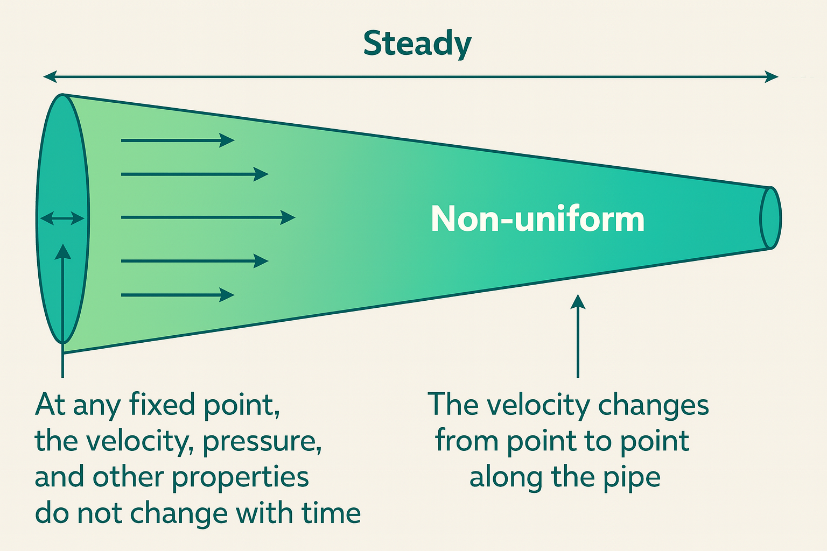
- Continuous Flow: occurs when at any time, the discharge at every section of the stream is the same (conservation of mass).
Incompressible fluids:
Compressible fluids:
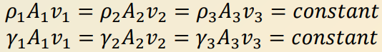
- Laminar Flow: when the path of individual particles does not cross or intersect.
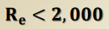
- Turbulent Flow: when the path of individual particles is irregular and continuously cross each other.
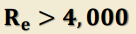
- One-Dimensional Flow: occurs when in an incompressible fluid, the direction and magnitude of the velocity at all points are identical.
- Two-Dimensional Flow: occurs when the fluid particles move in planes or parallel planes and the streamline patterns are identical in each plane.
- Streamlines: imaginary curves drawn through a fluid to indicate the direction of motion in various sections of the flow of the fluid system.
- Stream tubes: represents elementary portions of a flowing fluid bounded by a group of streamlines which confine the flow.
- Flow Nets: drawn to indicate flow patterns in case of two-dimensional flow or even three-dimensional flow.

E | ENERGY AND HEAD

- Energy possessed by a flowing fluid consists of the kinetic and potential energy.
- Potential energy may in turn be subdivided into energy due to position or elevation above a given datum, and energy due to pressure in the fluid.
- Amount of energy per pound or Newton of fluids is called the head.

Kinetic Energy
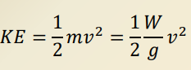
Therefore, kinetic or velocity head is:
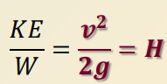
For circular pipe of diameter D flowing in full:
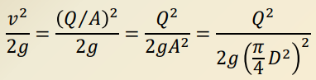
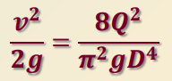

Potential Energy
Energy possessed by the fluid by virtue of its position or elevation with respect to a datum plane.
Elevation Energy
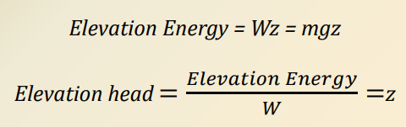
Pressure Energy
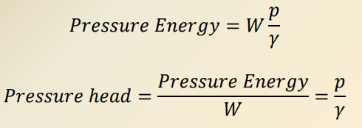

Total Flow Energy (E)
The total energy or head in a fluid flow is the sum of the kinetic and the potential energies. It can be summarized as:
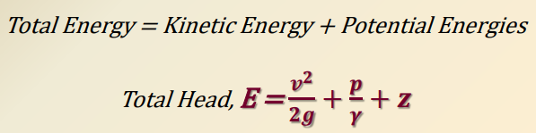

Power and Efficiency
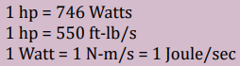

BERNOULLI’S ENERGY THEOREM
- Swiss mathematician and physicist: Daniel Bernoulli (1738)
- Results from the application of the principle of conservation of energy.
- As the speed of a moving fluid (liquid or gas) increases, the pressure within that fluid decreases.
- The total energy in a steadily flowing fluid system is constant along the flow path.
- An increase in the fluids speed must therefore be matched by a decrease in pressure.
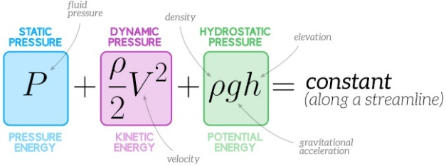

Continuity Equation
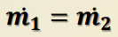
For incompressible fluids:
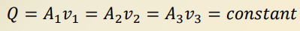
For compressible fluids:
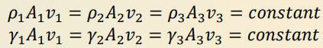

Energy Equation
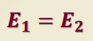
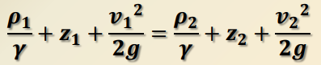

Momentum Equation
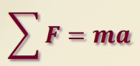
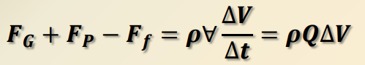

DARCY’S, MANNING’S, BERNOULLI’S, HEGEN-POISEUILLE
Darcy’s Equation | 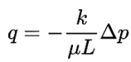 | Governs flow in aquifers and wells. Only applicable for laminar flow
Manning’s Equation | 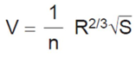 | Applies to uniform flow in open channels
Bernoulli’s Equation | 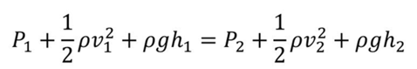 | Conservation of energy law for a flowing fluid
Hagen-Poiseuille Equation | 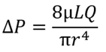 | Calculate the flow rate of a fluid through a pipe for laminar flow conditions.

Reynolds Number
Represents the ratio of inertial to viscous forces within a fluid
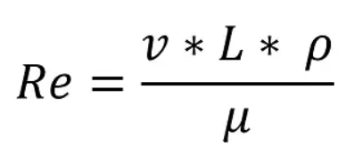
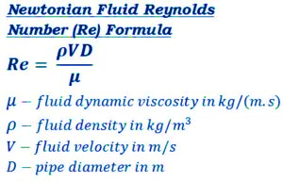

Prandtl Number
Relates the viscosity of a fluid to its thermal conductivity
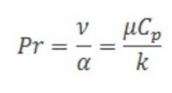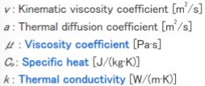

Nusselt Number
ratio of convective heat transfer to conductive heat transfer in a fluid system
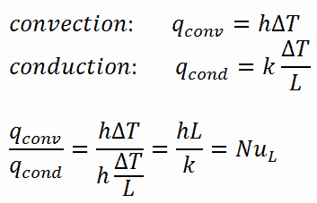

Avogadro’s Number
Number of units in one mole of any substance
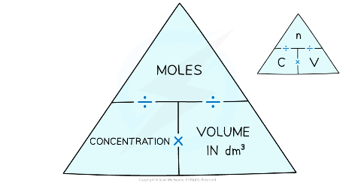

Froude’s Number
Dimensionless number which represents the ratio of inertial and gravitational forces value and describes different flow regimes of open channel flow
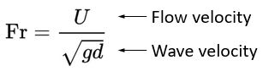
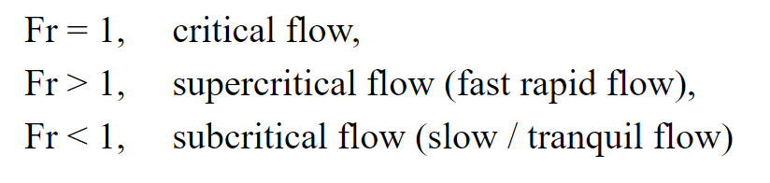

F | FLUID FLOW MEASUREMENT

DEVICE COEFFICIENTS

- Coefficient of Discharge, C or Cd
The ratio of the actual discharge through the device to the ideal or theoretical discharge which would occur without losses.
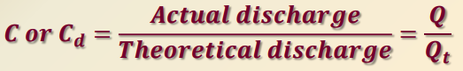

- Coefficient of Velocity, Cv
Ratio of the actual mean velocity to the ideal or theoretical velocity which would occur without any losses.
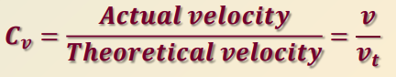

- Coefficient of Contraction, Cc
Ratio of the actual area of the contracted section of the stream or jet to the area of the opening through which the fluid flows.
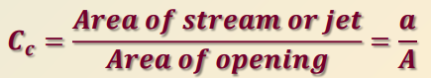

Relationship of the three coefficients
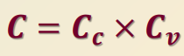

FLUID MECHANICS MEASURING INSTRUMENTS

INSTRUMENT
Manometer | 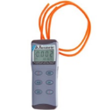  difference in pressure between two points  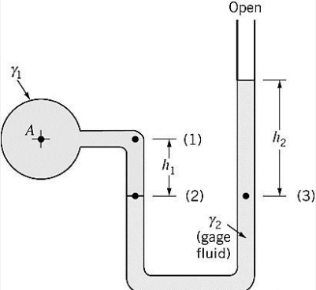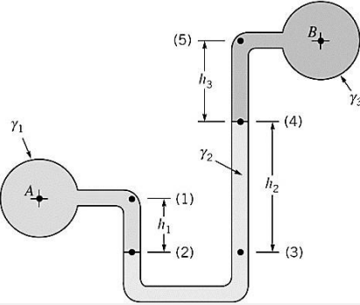
Venturi Meter | 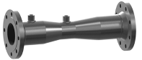  flow rate (discharge) of a fluid through a pipe
Pitot Tube | 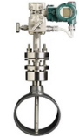  measure fluid flow velocity. It measures difference between stagnation pressure and static pressure to determine local flow velocity at a specific point.
Flowmeter | 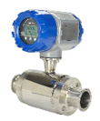  measure linear, nonlinear, mass, or volumetric flow rate of a liquid or gas.
Rheometer | 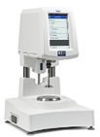  measures the viscoelastic properties of materials; viscosity, elasticity, stress, and strain. How materials changes over time or under different conditions.
Viscometer | 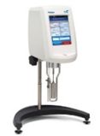  measures the viscosity of a fluid which is its resistance to flow. It quantifies how easily a fluid moves or deforms under applied force.
Hydrometer | 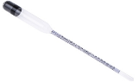  measures the specific gravity (or relative density) of a liquid

ORIFICE
It is an opening (usually circular) with a closed perimeter through which fluid flows.
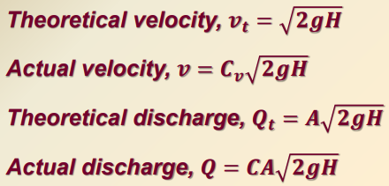
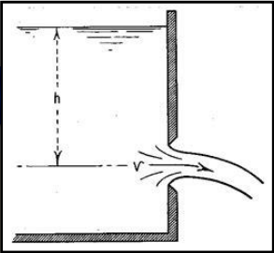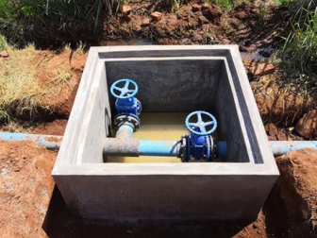

VENTURI METER
It is an instrument used in measuring the discharge through pipes.
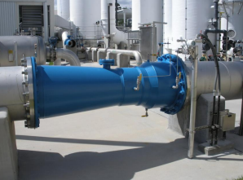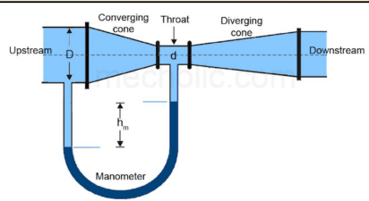

FLUME
In-line structure with a geometrically specified constriction built in an open channel such that the center line coincides with the center line of the channel in which the flow is to be measured.
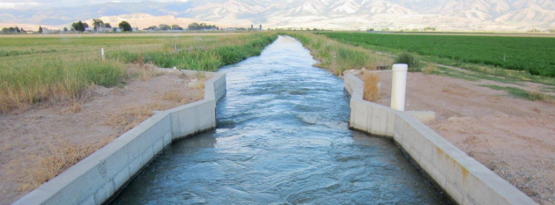

NOZZLE
A converging tube installed at the end of a pipe or hose for the purpose of increasing velocity of the issuing jet.
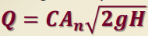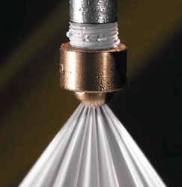

PITOT TUBE
“Henri Pitot” a bent (L-shaped or U-shaped) tube with both ends open and is used to measure the velocity of fluid flow or velocity of air flow.
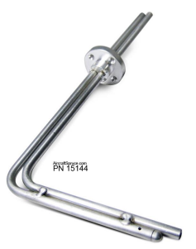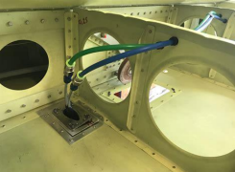

WEIRS
Overflow structures which are built cross an open channel for the purpose of measuring or controlling the flow of liquids.
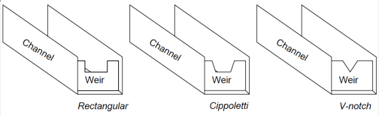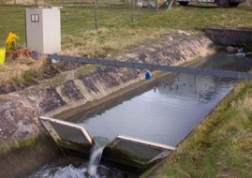

WIERS
Francis weir | 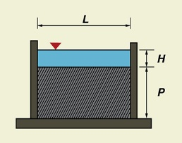 | $$Q=1.84LH^{3/2}$$
Francis weir with contraction | 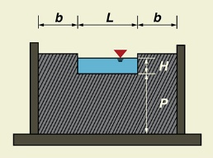 | $$Q=1.84(L-0.2H)H^{3/2}$$
Trapezoidal weir (Cipoletti) | 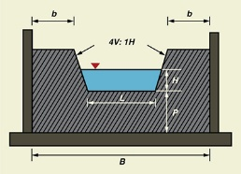 | $$Q=1.86LH^{3/2}$$
Triangular weir (90$°$) | 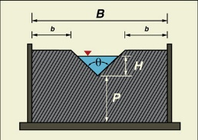 | $$Q=1.38H^{5/2}$$

G | FLUID FLOW IN PIPES

PIPES
- Closed conduits through which fluids or gases flows.
- Conduits (usually circular) which flow full.
- Conduits flowing partially full are called open channels.

TERMS
- Laminar Flow: when the path of individual fluid particles do not cross or intersect.
- Turbulent Flow: when the path of individual particles are irregular and continuously cross each other.
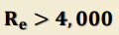
- Critical velocity: velocity below which all turbulence are damped out by the viscosity of the fluid. This is represented by a Reynold’s number of 2000.

Reynolds Number
Represents the ratio of inertial to viscous forces within a fluid
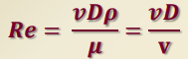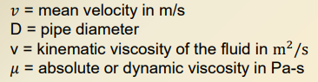
- Laminar Flow: Re < 2000
- Transitional Flow: 2000 > Re > 4000
- Turbulent Flow: Re > 4000

H | HEAD LOSSES IN PIPE FLOW

Darcy-Weisbach Formula
(pipe-friction equation)
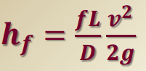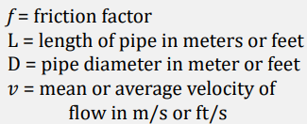

for circular pipe
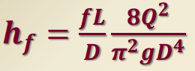

For Laminar Flow (Re < 2000)
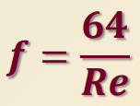

For Turbulent Flow (Re > 4000)
